A GUIDE FOR PARENTS

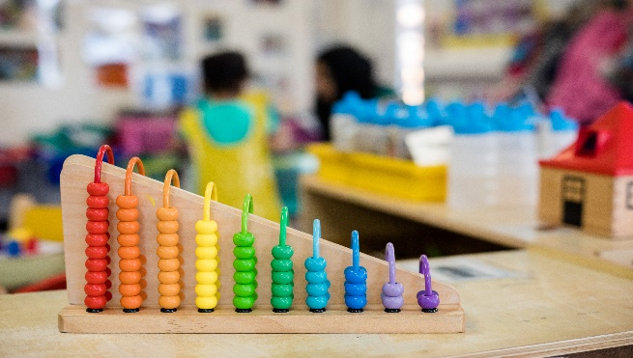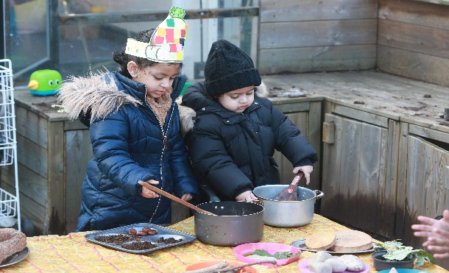

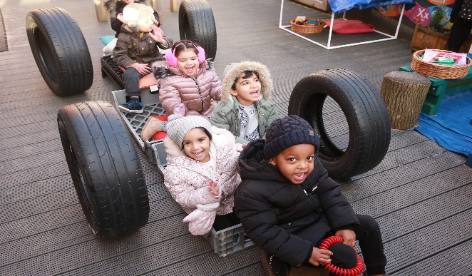

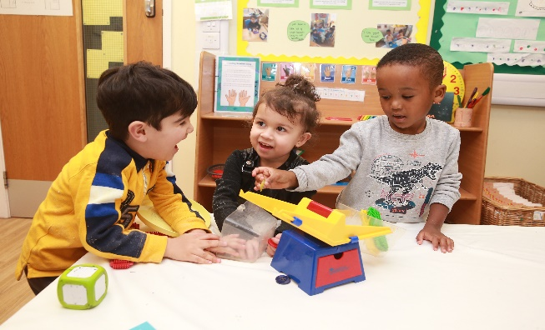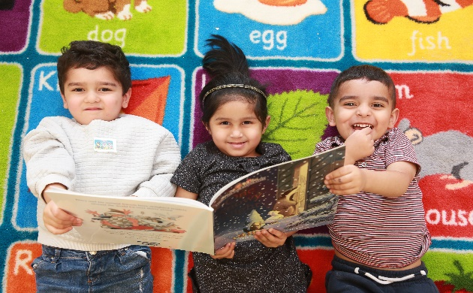

http://nursery.sunninghillprimary.net

Sunning Hill Primary School, Goldsmith Street, Bolton, BL3 6TR

Telephone: 01204 333588

Head Teacher: Miss Whalley

**Introduction**

This information booklet welcomes you and your child to the Nursery classes at Sunning Hill Primary School.

We are all looking forward to you joining us and we hope that your child’s stay with us will be a happy one. We want to ensure that your child enjoys his or her time at nursery and feels secure and cared for.

We hope that you will find this booklet useful. It is designed to answer some of the questions you may have about the nursery and it explains a little about what happens here. We have included some necessary reminders that will help the smooth running of the nursery and, most importantly, ensure the safety of your child.

**Our nursery aims:**

* To create a happy, stimulating environment where children will be encouraged and motivated to explore, discover and learn through a play based approach.
* To introduce young children to a wide range of experiences using practical learning opportunities appropriate to their ages and stages of development.
* To build positive relationships with parents so that we may support them in fostering the emotional, physical and social development of their children.

**Admission to Nursery**

Applications are invited at any time for admission to nursery. Application forms

are available from the school office or can be downloaded from the school’s website. Visits to both the Nursery and the main school are welcomed by appointment. Applications are placed on a waiting list and parents informed the term before their child is eligible to join.

**Admission Criteria**

The admission policy for nursery schools and classes is as follows:

The head teacher will allocate places in their nursery school/class as they become available, primarily on the age of the children. Head teachers may also take into account medical factors or serious social deprivation, which should normally be supported by independent evidence.

**Two year old unit.**

At present we have 15 morning and 15 afternoon places. Places are offered based on age and eligibility.

To qualify for a free place parents will need to complete an eligibility check. This may be completed by school or through childcare choices. If the school are completing this check, you will be asked to provide details such as parent and child full names, address, date of birth, national insurance number, the child’s birth certificate red book. Asylum seekers may need to provide their card as evidence.

To be eligible for a free place you must be receiving one of the following:-

* Income Support
* income-based Jobseeker’s Allowance
* income-related Employment and Support Allowance
* support under Part VI of the Immigration and Asylum Act 1999
* the guaranteed element of Pension Credit
* Child Tax Credit (provided you’re not also entitled to Working Tax Credit and have an annual gross income of no more than £16,190)
* Working Tax Credit run-on - paid for 4 weeks after you stop qualifying for Working Tax Credit
* Universal Credit - if you apply on or after 1 April 2018 your household income must be less than £7,400 a year (after tax and not including any benefits you get)

Remaining sessions may be offered to paying parents at a cost of £95.00 for 15 hours, either morning or afternoon sessions.

**Three year old unit**

We have 52 morning and 52 afternoon places, inclusive of a maximum of 20 full time 30 hour places, which include lunchtime provision.

15 hour place opions are either :-

* **Morning session - Monday to Friday 8.30am to 11.30am**
* **Afternoon sessions Monday to Thursday 12.15pm to 3.30pm**

**Fridays 12.30 – 2.30pm**

30 hour place options, **subject to eligibility.**

To be eligible for a free place you, and any partner, must each expect to earn (on average) the equivalent of working 16 hours a week at your national minimum wage (£183.04 at the National Living Wage, less if you are on the National Minimum Wage)

If you, or your partner, are on maternity, paternity or adoption leave, or you're unable to work because you are disabled or have caring responsibilities, you could still be eligible.

You can't get 30 hours free childcare if you, or your partner, expect to earn £100,000 or more.

**Places are allocated on a first come first served basis.**

**30 hour place - length of day options**

|  |  |  |  |  |  |
| --- | --- | --- | --- | --- | --- |
| **Option** | **Description** | **Charge** | **Lunch Option**  **(Tick one option)** | | **Tick one option only** |
| **1**  ***Standard***  ***offer*** | Our standard offer is 8.30am - 3.30pm Monday to Thursday and 8.30am - 2.30pm Friday, term time only. **Equating to 34 hours of provision each week**. | ***£20.00 per week*** * | Pack lunch provided by Parent | Paid School Meal |  |
|  | | | | | |
| **2** | 8.30am to 2.30pm daily, term time only. | £0.00 | Pack lunch provided by Parent | Paid School Meal |  |
|  | | | | | |
| **3** | 8.30am to 11.30am. Your child will need to be collected for lunch at 11.30am and return to school at 12.15pm until 3.30pm Monday to Thursday and 12.30pm to 2.30pm Friday. | £0.00 | Not Applicable | |  |

**Starting Nursery**

We are aware of the tremendous input that you, as parents, have already made in the education of your child and we acknowledge your role as the child’s first educator. From birth, children learn many things. You have already played an important part in this process of learning and we look forward to developing a partnership with you in these valuable early years.

Starting nursery is a very exciting time for young children and together we can make it a very happy and rewarding time. Before starting nursery, talk to your child about coming to nursery and about the things they will be doing and the people they will be meeting. It is helpful to use our names so that they will be familiar with them.

It is important to remember that young children vary in the way in which they react to new experiences so do allow your child plenty of time to get used to nursery – some children may take longer to settle than others.

For the first 2-4 days the children will have a staggered transition into nursery.

**For nursery 3’s** this will usually be day 1 they will attend for and hour, day 2 they will attend for 2 hours, day 3 they will attend for the full 3 hours.

**For nursery 2’s** this will usually be day 1 they will attend for an hour, day 2 they will attend for an hour and a half, day 3 they will attend for 2 hours, day 4 they will attend for 2 and a half hours and day 5 they will attend for the full 3 hours.

**This can be altered on a case by case basis as is the child’s need.**

**Moving on to School**

Admission to the reception class at Sunning Hill is managed by the Local Authority and places are allocated according to their admissions policy. Our school prospectus can be obtained from the office.

**Please be aware that children who have been in the nursery are not automatically guaranteed a place in the reception class. You can visit the Bolton Council website and search for primary school admissions to register your child.**

We expect that many of our nursery children will transfer to our school and throughout your child’s time in the nursery, we aim to foster a close relationship with the staff and children in the main school so that there will be a smooth transition from nursery to the reception class. Teaching staff in the reception class and Nursery work together closely to ensure consistency throughout the early years. Our nursery team are always available to liaise with reception teachers in other school and will forward relevant information for those children who do not transfer to our Reception class.

**If you need help completing your child’s school application please ask at the office for more information.**

**We advise all parents to choose 3 schools, as choosing 1 school does not guarantee you a place there and may mean the school you are allocated is further away**.

**How you can help us**

**Bringing and collecting the children:**

* Access to nursery is via the key stage 1 playground.
* Your child MUST be brought and collected by a person over the age of 16 years.
* At the beginning of the session please hand your child over to a member of the nursery staff before you leave. Similarly at the end of the session please wait on the playground and the nursery staff will bring the children to the door and hand them over to parents.
* Please tell us if someone different will be collecting your child or if you are going to be late for any reason. Also let us know if you need to collect your child early.
* **We would be grateful if you would ensure that your child is brought on time at the beginning of each session and similarly collected at the end of each session, as children can become upset if they always arrive late or are left until last. This can also lead to children missing vital learning inputs.**

**“Stay and Play”**

In nursery 3 year old provision Parents/carers are invited to spend up to 15 minutes with their child for Stay and Play every Monday and Wednesday:

8:30 - 8:45am

12:15 - 12:30pm

This is a lovely opportunity for you to find out what your child has been doing in nursery and chat to the staff.

In nursery 2 year old provision Parents/carers are invited to spend up to 15 minutes with their child for Stay and Play daily:

8.30 - 8.45am or 12.15-12.30pm- Monday to Thursday

8.30 - 8.45am or 12.30 – 12.45pm - Friday

This is a lovely opportunity for you to find out what your child has been doing in nursery and chat to the staff.

In order for this to run smoothly we ask that you take note of the following:

1. You limit the number of adults to 1 per child to avoid congestion.
2. Younger children (pre 2 year old nursery) must be supervised by parents.
3. Staff will be needed to supervise children within the nursery and monitor parents arriving and leaving. If you need to see the Nursery Teacher to discuss any issue at length please make an appointment at the school office.
4. Please leave your child at the end of Stay and Play. If your child is upset please follow the advice of our Nursery staff. We encourage parents to phone school later on in the day if you are at all anxious about your child settling.

**Absences & illness**

* We ask that you establish good habits with your child by bringing him/her to Nursery on time and maintaining a good pattern of attendance.
* Please ensure that we have up to date information regarding contact numbers so that we can get in touch with you if your child becomes unwell.
* Please contact the school and let us know if your child is going to be absent and unable to attend Nursery.
* If your child has had sickness or diarrhoea please keep him/her at home for 48 hours.
* If your child has German measles/chicken pox please contact us immediately so that we can inform parents in case of anyone being in the early stages of pregnancy.
* A school holiday list will be given to you when your child enters Nursery. Please let us know in writing if you have to go away on holiday during term time.

**Medicines**

* We would ask that you usually arrange to give prescribed medicine during the time your child is at home or come into Nursery yourself at the necessary time. Exceptional circumstances can be discussed based on your child’s need. For more information please see the medicines policy.

**Toileting**

**three and four year olds**

We ask that all parents achieve or begin toilet training before their child starts nursery. Advice will be given to parents during the transition sessions. Please inform staff if you require support in this area and they will ensure that they continue toilet training with you. For children who are not fully toilet trained please provide a full change of clothes and underwear or pull ups in case of toilet accidents.

We recommend that children who are toilet training wear knickers or underpants but prior to this children in 3 year old nusery should be in pull ups, not nappies as pull ups help them prepare for toilet training.

We understand that children with additional needs may not be ready for toilet training and we will work with parents based on the child’s needs.

**two year olds**

We understand that many of the children will not be toilet trained when they start nursery, please be reassured the nursery unit has changing facilities. **Please send nappies, wipes and cream (if required) with the extra set of clothing.** Any soiled underwear will be placed in a bag and sent home at the end of the session.

Staff are available to provide advise and will work closely with parents to support those children who are toilet training, particularly when moving into our three year old unit.

**In the event of an injury**

Should your child have a slight bump or possibly a fall during play this will be dealt with appropriately by a trained paediatric first aider. Minor grazes and scrapes are cleaned using only cold water and occasionally a plaster may be applied. A standard ‘bumped head’ letter will be issued if needed.

If the accident is of a more serious nature, you would be contacted immediately and if necessary the emergency services would be called.

**Children with Asthma/Allergies**

Please ensure that we have up to date information in nursery. We need to know about any food/other allergies. If your child requires an inhaler we will keep one in nursery.

**Sun Creams & Caps**

Please apply sun block, preferably SPF 30+ before they come to nursery even if it doesn’t look like it will be hot. In the event that your child has not had sunscreen applied prior to arrival, with your permission Early-Years staff will apply suncream when necessary.

We also recommend sending your child with a sun cap preferably the kind with material which covers the back of the neck. We do provide shaded areas for children to play.

**Clothes for the nursery**

* Please arrange for your child to be sensibly and comfortably dressed in practical clothes that he/she can manage at the toilet, can participate in ‘messy activities’ and can easily take off / put on. It is important that your child is able to develop independence.
* Many parents are opting for their child to wear the Sunning Hill uniform and details can be obtained from the school office. PLEASE ENSURE ALL ITEMS OF CLOTHING ARE CLEARLY NAMED.
* Every child will have his or her own coat peg with name and picture. Please ensure that your child brings a coat to nursery EVERY DAY as outside play is available at all times except in dangerous weather. It is advisable to name coats and hats.
* If your child has a ‘toilet accident’ in Nursery we will change him/her and provide clean clothes if they have not brought in their own. Please return the nursery clothes as soon as possible as our supplies are limited.
* Footwear should be of a sensible design and suitable for both indoor and outdoor play. Velcro fastenings are particularly useful and shoes must be low heeled. We ask that your child does not wear open toed shoes/sandals even in hot weather for his/her own safety.If Wellington boots are worn to Nursery during bad weather please bring a plastic bag to hang them on your child’s peg and ensure they are named.

**Personal Items**

* In keeping with Local Authority Health and Safety guidelines we ask that children do not wear jewellery at Nursery so please leave rings, bracelets, chains and necklaces at home.
* Children with pierced ears may ONLY wear stud type earrings.
* We ask your child not to bring his/her own toys or personal possessions from home. Occasionally we may ask your child to bring in something connected with our current theme and we ask that you encourage him/her to do so.

**Reading**

Children will be able to choose books from the nursery library with the support of the teacher. We encourage parents to share stories with their children to encourage a love of reading.

**Snack Money**

There is a small termly charge for families wanting their child to have a daily healthy snack. Payments must be made online through Tucasi. When your child starts nursery you will be given a link code.

Milk, water and fruit is provided for all children. Please let us know if your child is not allowed to eat certain foods.

**Partnership with parents/carers**

As parents, you are the first educators of your children. We believe in a close partnership with parents and staff as we join you in educating your child.

We want to work closely with you. Good communication between staff and parents enables us to inform each other of relevant matters concerning your child. We appreciate being informed of any change at home that might affect your child and will treat anything you tell us in strict confidence.

We hold regular parents’ evenings when you will be invited to discuss how your child has settled and how he/she is progressing. However, there is no need to wait for these if you have questions or concerns. We want you to feel welcome at the nursery and we will always have time for you.

We keep you informed of events in school through our regular newsletters. Please take time out to read them.

**Disability Equality/Racial Equality/Gender Equality**

The school is committed to being an inclusive community by valuing and caring for every one of its members, adults as well as children. All incidents that involve discrimination concerning the protected characteristics under the Equality Act 2010 are challenged and acted upon.

**Child Protection Procedures**

The school takes its role in Child Protection very seriously. The school has five senior leaders who are trained as designated persons for child protection. The school adheres to the procedures and guidelines detailed in the document ‘Framework for Action, for all children, young people and families in Bolton’ , as drawn up by Bolton Safeguarding Board. Staff receive appropriate foundation training in child protection. A copy of the Child Protection Policy can be found on the school website.

**How you can help your child at home**

Each week the teacher will make a brief overview of the week’s activities available on the learning platform “Class Dojo” so that you can discuss with your child what they are learning about. They will also be given simple, home learning tasks on Dojo to complete with yourself. You will be given information on how to create a Dojo account when your child begins nursery. You may also wish to contribute by sharing photographs and experiences that will extend their learning and staff will share photographs of what the children have been enjoying at Nursery.

Encourage your child to:

* Use the toilet independently
* Wash and dry their hands
* Dress and undress independently
* Recognise their own name
* Use a knife, fork and spoon
* Tidy up his/her toys
* Chat with your child about everyday events, outings and special days
* Ready stories with your child and look at books together as often as possible
* Encourage your child to sing and make up their own songs
* Play games that require your child to concentrate for a short period of time such as dominoes or snap
* Take pary in pretend play with your child (shop, being mummy etc.)
* Encourage your child to mark-making with pencil, pens, crayons and chalk
* Give your child the opportunity to use a safe pair of scissors to practise cutting a variety of materials
* Encourage your child to move indifferent ways – run, hop, skips, climb etc.

**Safeguarding & Child Protection - Letter from the School Governors**

The Governors are keen to make sure our parents are fully informed about the school’s role in keeping children safe. This is an area that has had a very high profile over the last year in all schools and is now inspected thoroughly as part of Ofsted procedures. Like most other schools, we have recently reviewed our policies and procedures in this area and all staff have now received training in safeguarding and child protection. Sometimes, this means staff have to take certain actions that may make parents and families feel uncomfortable. The purpose of this booklet is to inform parents so they understand the Framework for Action, within which the school (and all other organisations working with children) have a duty to operate.

**What happens if a member of staff is concerned about a child?**

All children have an absolute right to a childhood free from abuse, neglect or exploitation. Children learn best and thrive when they are well-looked after and feel safe and secure. Staff are responsible for the well-being of pupils in their care and have a duty to act upon any concerns, no matter how minor they may appear. Concerns may be linked to medical issues, personal hygiene (which can lead to name calling or bullying), behaviour, weight loss or gain or other areas. Usually, staff will discuss any concerns with parents and agree any actions or support. In some instances, this may lead to a referral to an outside agency e.g. the School Nurse or Behaviour Support and this may result in external agencies working with the child or family to support them in addressing the area of concern.

**What happens when a child or adult makes a disclosure?**

Children or parents/carers may disclose information to staff which means staff have a duty to take immediate action. This tends to be where a child tells an adult that they have been hit or abused in some way, but sometimes such a disclosure is made by a parent or carer. The school must then seek and follow advice from Referral and Assessment or from the team who deal with abuse by adults in a position of trust. It is not the school’s role to investigate the incident but we are required to follow locally agreed safeguarding procedures and to pass on information. Following a referral, a social worker may wish to speak to any children involved individually and/or to the parent or carer and in some cases, a medical may also be necessary. In many cases, after an initial investigation, the case is closed.

**What is the legal position?**

Any adult working with children in a position of trust should never hit children. Reasonable restraint may be used at school if a child’s behaviour is posing a threat to themself, others or their behaviour is affecting the good-order or discipline of the pupils. Parents are not allowed to hit children with any sort of implement or to leave any type of mark when handling children. When a child or adult discloses that this may have happened, the police may also be involved in the investigation. This is beyond the control of the school.

**How does school safeguard children?**

The Governing Body has agreed several policies and procedures to ensure pupils’ safety and all staff are responsible for implementing these. Some of the main areas are listed below:

* Child Protection – all staff are trained to follow procedures.
* Safer Recruitment – staff and governors, who are involved in appointments, undergo training.
* Health and Safety – to ensure a safe environment in all activities and educate pupils about personal safety.
* Attendance – this is monitored closely as poor attendance can indicate wider problems.
* Anti-bullying & Behaviour – we promote positive behaviour and encourage pupils to talk to an adult if they are being bullied.
* Equality (including discrimination) – to ensure equal opportunities for all our pupils.
* Medical Conditions – to support pupils with particular needs.
* Educational Visits – to enrich the curriculum, while minimising risk.
* E-Safety and Internet Safety – to raise awareness and educate about possible risks.
* School Security – to make the school site as safe as possible.

Further details of these policies and many others can be found in the policies section of our website [www.sunninghillprimary.net](http://www.sunninghillprimary.net)

**What role can parents play**?

Parents play a key role in helping their children to be well-looked after and feel safe and secure. Areas that can make a big difference to the well-being of a child include ensuring that their children:

* Eat healthily at regular intervals (breakfast is the most important meal).
* Get regular exercise and rest (most children need about 10 hours sleep).
* Wash regularly and have clean, appropriate clothing (e.g. ensuring footwear fits).
* Understand the importance of attending school every day and arriving on time.
* Understand possible risks e.g. road safety, Internet safety etc.
* Take responsibility for their own behaviour and show others respect.
* Understand the importance of telling the truth.
* Have their medical needs met.
* Understand that they should not use violence to resolve conflict.
* Understand that they can talk to adults if they have any worries.